MPM3D Code Documentation

Cameron Rodriguez, Tsung-Hui Huang

Introduction
Altogether, the MPM3D program contains three different files: the “Input File”, the “Initialization File”, and the “Main File”. Their respective functions are as follows:

- “Input File” (Input_0.txt): A text file used to input all problem description parameters. This includes material model and properties, specific MPM numerical parameters, optional stabilization techniques, etc. Any changes made to the “Input File” will be read directly by both the “Initialization File” and “Main File” when the simulation is run.

$→$ Input: User defined inputs

$→$ Output: None

- “Initialization File” (MAIN_Initialize.py): A Python script used to read the given mesh and geometry generated by GMSH, and subsequently output the following geometric parameters:
  - Particle position ($x_{p}$)
  - Particle normal vector ($n_{p}$)
  - Particle volume ($V_{p}$)
  - Particle surface area ($S_{p}$)
  - Indices that define the BodyID (assigned to each mesh) and NodeID (assigned to each particle)

$→$ Input: The “Input File”, and the GMSH generated mesh file (.msh)

$→$ Output: Several geometric parameters, and a plot of the particle distribution and normal vectors.

- “Main File” (MAIN.py): A Python script used to run the MPM simulation. It will read the “Input File” to define the problem setting and parameters, as well as read the geometric parameters generated by the “Initialization File”.

$→$ Input: The “Input File”, and the geometric parameters generated by the “Initialization File”

$→$ Output: A folder of .vtk files that can be read and displayed using ParaView

Input File
The “Input file” is made up of a number of sections, each containing a related set of numerical input parameters.

Basic Settings
Here, the basic settings for the problem and post-processing are given. An example is shown below in Figure 1.

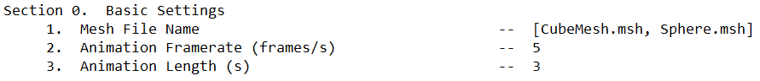
Figure 1. Example “Basic Settings” input.

- Mesh File Name: The file name (including $.msh$) of each of the meshes used in the simulation. There can be more than one, separated by a single comma.

- Animation Framerate: The desired number of frames per second from the final animation exported from ParaView (see Section. 3.1.4).

- Animation Length: The desired length of the final animation exported from ParaView (see Section. 3.1.4).

Numerical Setting
Here, the basic inputs for the conventional MPM formulation are given. An example is shown below in Figure 2.

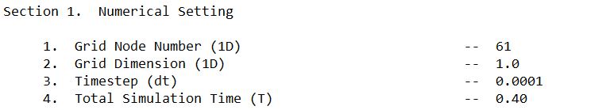
Figure 2. Example “Numerical Setting” input.

- Grid Node Number: The number of grid nodes that span one side of the background grid (because the background grid is a cube with uniformly spaced grid nodes, each side will contain the same amount of grid nodes).

- Grid Dimension: The physical length of one side of the background grid (because the background grid is a cube, each side will have the same length).

- Timestep: The $∆t$ between each timestep of the simulation.

- Total Simulation Time: The total amount of time that the simulation will run.

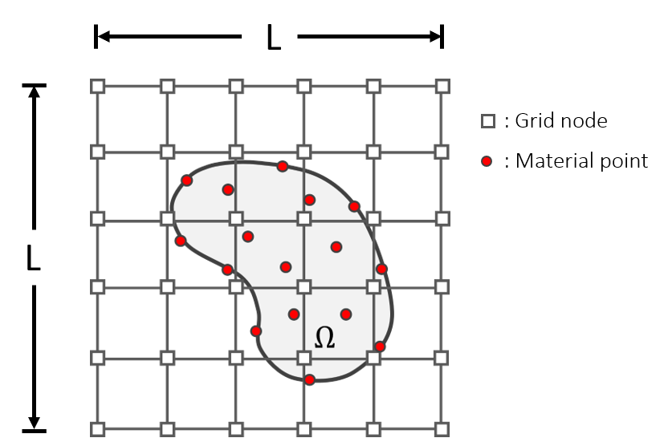
Figure 3. A 2D representation of the MPM numerical setting. In this representation, the Grid Node Number is 6, and the Grid Dimension is $L$.

Material Model
The “Material Model” section contains four different options, each with their own related input parameters. An example is shown below in Figure 4.

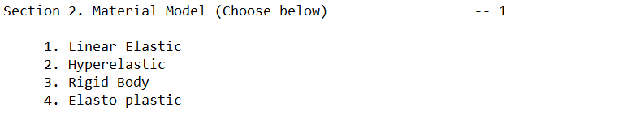
Figure 4. Example “Material Model” input.

Linear Elastic
For a linear elastic material, stress is calculated as a linear function of strain as follows:
$$σ=\left[Ktr\left(ε\right)\right]I+2με$$ | (1)
The MPM code uses an incremental form to update stress ($σ^{t_{n+1}}$ is a function of $σ^{t_{n}}$). The particle stress is therefore given as:
$$σ_{p}^{t_{n+1}}=σ_{p}^{t_{n}}+\left[Ktr\left(∆ε_{p}\right)\right]I+2μ{∆ε}_{p}$$ | (2)
Where $∆ε_{p}$ is the particle strain increment between timesteps:
$$∆ε_{p}=∆tD_{p}^{t_{n+1}}$$ | (3)
Where $D_{p}^{t_{n+1}}$ is the particle strain rate:
$$D_{p}^{t_{n+1}}=\frac{1}{2}\left[C_{p}^{t_{n+1}}+{\left(C_{p}^{t_{n+1}}\right)}^{T}\right]$$ | (4)
And $C_{p}^{t_{n+1}}$is the particle velocity gradient.

Hyperelastic
The stress is calculated using an Ogden neo-Hookean material model, in which the Cauchy stress is given as:
$$σ=μJ^{-1}\left(FF^{T}-I\right)+λ\left(J-1\right)I$$ | (5)
Where is $F$ the deformation gradient written as:
$$F_{ij}=\frac{∂x_{i}}{∂X_{j}}=\left[\begin{matrix}\frac{∂x_{1}}{∂X_{1}} & \frac{∂x_{1}}{∂X_{2}} & \frac{∂x_{1}}{∂X_{3}} \\ \frac{∂x_{2}}{∂X_{1}} & \frac{∂x_{2}}{∂X_{2}} & \frac{∂x_{2}}{∂X_{3}} \\ \frac{∂x_{3}}{∂X_{1}} & \frac{∂x_{3}}{∂X_{2}} & \frac{∂x_{3}}{∂X_{3}}\end{matrix}\right]$$ | (6)
And $J$ is the determinant of the deformation gradient: $J=det⁡(F)$.

The MPM code uses a total form ($σ^{t_{n+1}}$ is not a function of $σ^{t_{n}}$), and the particle stress update is written as:
$$σ_{p}=μJ_{p}^{-1}\left(F_{p}F_{p}^{T}-I\right)+λ\left(J_{p}-1\right)I$$ | (7)
Where the particle deformation gradient is updated as:
$F_{p}^{t_{n+1}}=\left(I+C_{p}^{t_{n+1}}∆t\right)$ $F_{p}^{t_{n}}$ | (8)
And $J_{p}=det⁡(F_{p})$.

Rigid Body
For the case of a rigid body, the entire domain moves at a constant velocity. Therefore, the particle velocity gradient $C_{p}=0$. The deformation gradient update can then be rewritten as:
$$C_{p}=0→F_{p}^{t_{n+1}}=\left(I+C_{p}^{t_{n+1}}∆t\right)F_{p}^{t_{n}}$$  $=\left(I+0∆t\right)F_{p}^{t_{n}}$  $=F_{p}^{t_{n}}$ | (9)
Because $F_{p}^{{t=t}_{0}}=I$, $F_{p}^{t_{n}}=I$ for every timestep of the simulation.

Calculate stress using the Ogden neo-Hookean material model:
$$σ_{p}=μJ_{p}^{-1}\left(F_{p}F_{p}^{T}-I\right)+λ\left(J_{p}-1\right)I=0$$ | (10)
Therefore, the particle stress is equal to zero everywhere.

Elasto-plastic
I use the exact same formulation as this video:

https://www.youtube.com/watch?v=HJqECZXlEas

This video is also very helpful:

https://www.youtube.com/watch?v=Wx8CN4lY8mY&t=520s

Material Parameters
Here, the basic inputs for the conventional MPM formulation are given. An example is shown below in Figure 5.

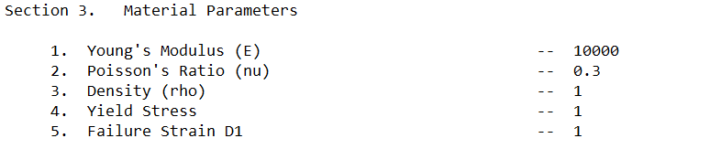
Figure 5. Example “Material Parameters” input.

- Young’s Modulus: $E$

- Poisson’s ratio: $ν$

- Density: $ρ=\frac{m}{v}$

- Yield Stress: $σ_{y}$ is only used for the elasto-plastic material model. It denotes the von Mises stress at which plastic deformation starts to occur.

Problem Setting
Here, the basic parameters that define the problem setting are given. An example is shown below in Figure 6.

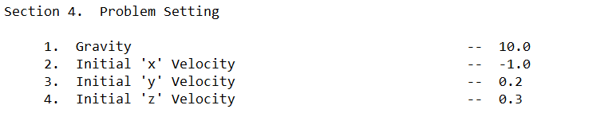
Figure 6. Example “Problem Setting” input.

- Gravity: The body force $g$ applied to the entire domain. The direction is by default pointed in the negative $z$ direction.

- Initial $x$ velocity: The $x$ component of the initial velocity

- Initial $x$ velocity: The $y$ component of the initial velocity

- Initial $x$ velocity: The $z$ component of the initial velocity

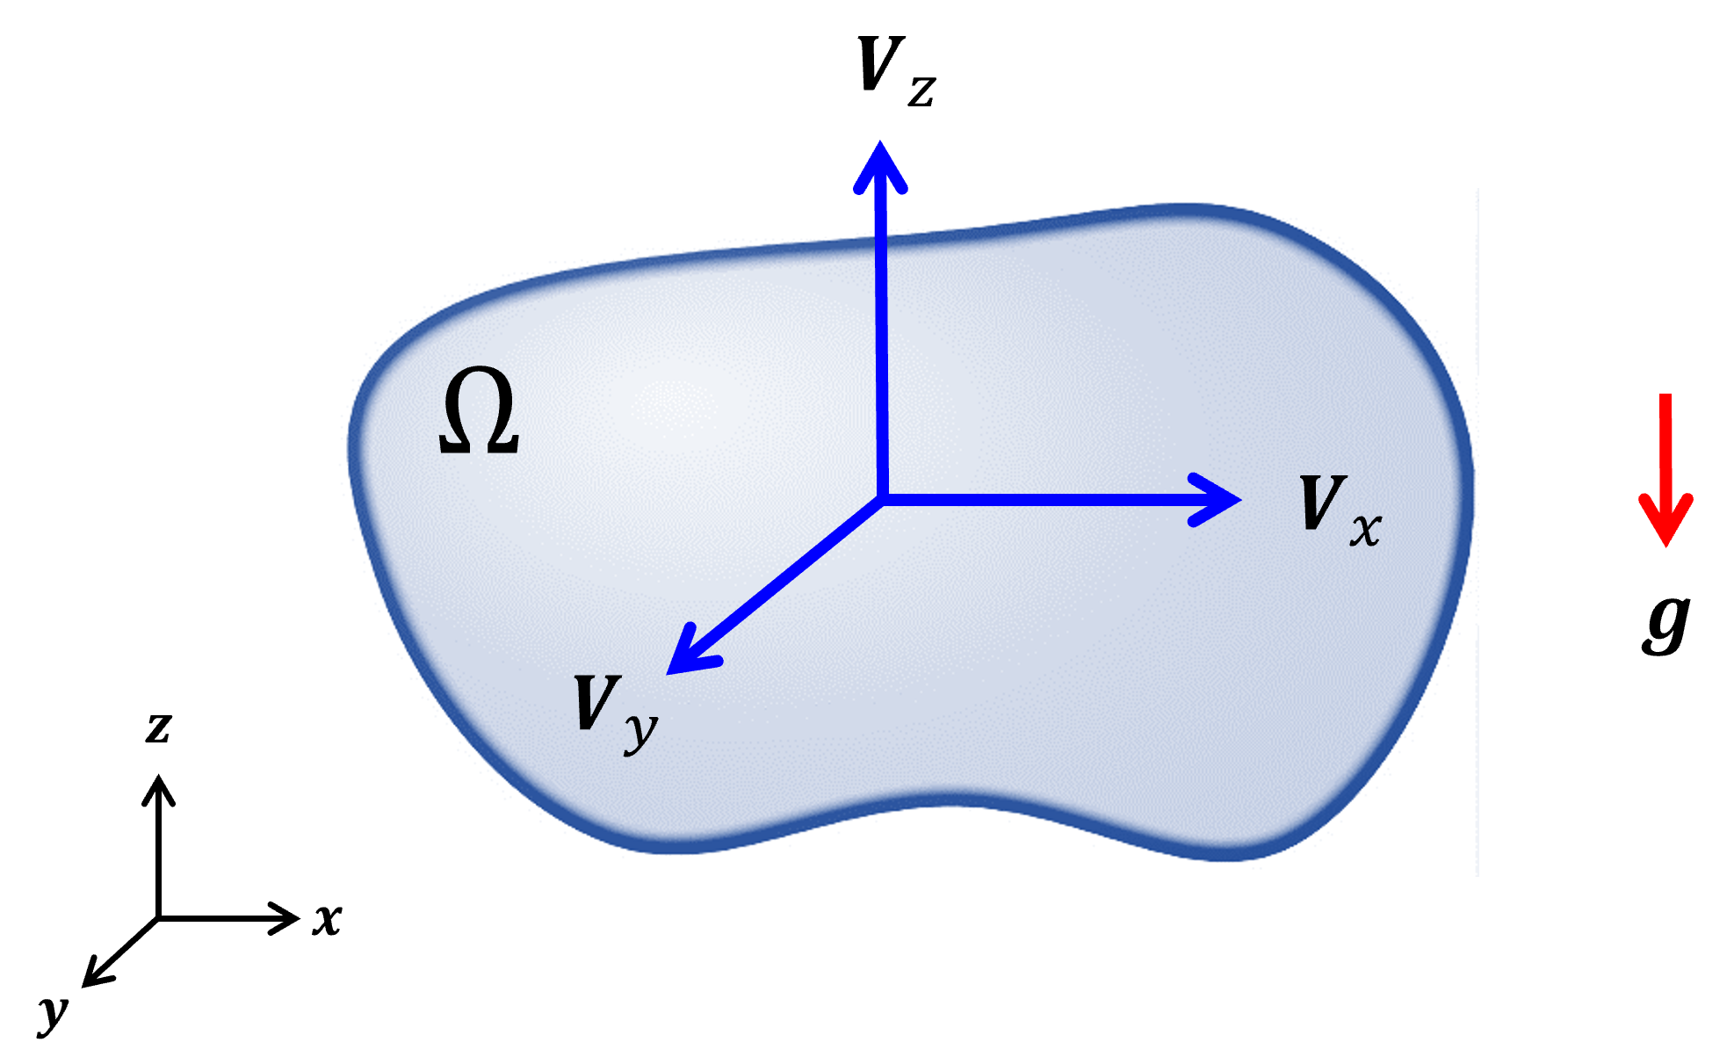
Figure 7. A geometric representation of domain $Ω$ with initial velocity $\left[v_{x},v_{y},v_{z}\right]$ and body force $g$.

Particle Update Methods
During both the Particle-To-Grid (P2G) and Grid-To-Particle (G2P) steps within the MPM algorithm, there are a variety of options for performing interpolation between the particle and background grid. This section will introduce each one, as well as briefly detail some of the advantages and disadvantages of each. An example of the proper input is shown below in Figure 8.

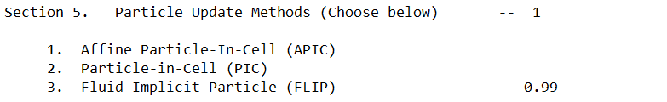
Figure 8. Example “Particle Update Methods” input. Note: The input for the FLIP option 3 denotes the blending parameter between FLIP and APIC (see Section 2.6.3 below). This is only implemented when the FLIP method is used.

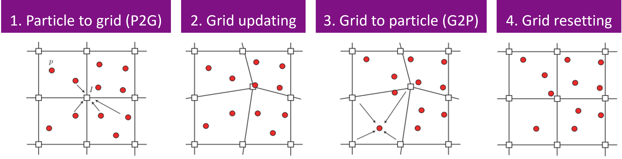
Figure 9. The four steps of the MPM algorithm. This section introduces various techniques for performing the 1. Particle-To-Grid (P2G) and 3. Grid-To-Particle (G2P) steps.

Particle-In-Cell (PIC)
PIC is the standard method to perform P2G and G2P interpolation for the conventional MPM formulation. It assumes a locally constant velocity field surrounding each particle.

Using PIC, the P2G interpolation is given as:
$$v_{I}^{t_{n}}=\sum_{p}^{ }{Ψ_{I}\left(x_{p}^{t_{n}}\right)v_{p}^{t_{n}}}$$ | (11)
And the G2P interpolation is given as:
$$v_{p}^{t_{n+1}}=\sum_{I}^{ }{Ψ_{I}\left(x_{p}^{t_{n}}\right)v_{I}^{t_{n+1}}}$$ | (12)
The PIC formulation has been shown to be extremely dissipative, and produces overly stiff material behavior.

Affine Particle-In-Cell (APIC)
APIC is another common method to perform P2G interpolation within the MPM formulation. It assumes a locally linear velocity field surrounding each particle. To do so, the APIC formulation makes use of the previously calculated particle velocity gradient $C_{p}$ to account for how the particle velocity may change linearly in space across the distance between the particle and the surrounding grid nodes.

Using APIC, the P2G interpolation is given as:
$$v_{I}^{t_{n}}=\sum_{p}^{ }{Ψ_{I}\left(x_{p}^{t_{n}}\right)\left[v_{p}^{t_{n}}+C_{p}^{t_{n}}\left(x_{I}-x_{p}\right)\right]}$$ | (13)
Where the additional term shown in blue denotes the linear change in velocity between the grid node position $x_{I}$ and the particle position $x_{p}$.

And the G2P interpolation is given as (the same as PIC):
$$v_{p}^{t_{n+1}}=\sum_{I}^{ }{Ψ_{I}\left(x_{p}^{t_{n}}\right)v_{I}^{t_{n+1}}}$$ | (14)
APIC has been shown to recover linear and angular momentum, and produces significantly less dissipative results when compared to using PIC.

Fluid Implicit Particle-In-Cell (FLIP)
FLIP is an alternative way to perform the G2P step of the MPM formulation. Whereas both PIC and APIC interpolate the updated particle velocity ($v_{p}^{t_{n+1}}$) directly using the updated grid velocity ($v_{I}^{t_{n+1}})$, FLIP uses an incremental approach (in which $v_{p}^{t_{n+1}}$is a function of $v_{p}^{t_{n}}$), where the updated particle velocity is calculated using the grid velocity increment.

Using FLIP, the P2G interpolation is performed using the same technique as PIC:
$$v_{I}^{t_{n}}=\sum_{p}^{ }{Ψ_{I}\left(x_{p}^{t_{n}}\right)v_{p}^{t_{n}}}$$ | (15)
Whereas the G2P interpolation is performed as follows:
$$v_{p}^{t_{n+1}}=v_{p}^{t_{n}}+\sum_{I}^{ }{Ψ_{I}\left(x_{p}^{t_{n}}\right)\left[v_{I}^{t_{n+1}}-v_{I}^{t_{n}}\right]}$$ | (16)
Although FLIP is less dissipative compared to PIC, is has been shown to produce unstable material behavior.

To overcome this instability, it is common to blend both FLIP and PIC / APIC techniques. This allows the formulation to recover the energy conservation properties of FLIP, while maintaining the stability of PIC / APIC. This blending is calculated for the G2P step as follows:
$$v_{p}^{t_{n+1}}=α\left[v_{p}^{t_{n}}+\sum_{I}^{ }{Ψ_{I}\left(x_{p}^{t_{n}}\right)\left[v_{I}^{t_{n+1}}-v_{I}^{t_{n}}\right]}\right]+\left(1-α\right)\left[\sum_{I}^{ }{Ψ_{I}\left(x_{p}^{t_{n}}\right)v_{I}^{t_{n+1}}}\right]$$ | (17)
Where the term in blue is the FLIP velocity, and the term in red is the PIC / APIC velocity. $α$ is therefore a blending parameter such that $α∈\left[0,1\right]$. $α=0$ recovers the PIC / APIC formulation, and $α=1$ recovers the FLIP formulation.

Remark: When using this blending technique, $0.95<α<0.99$ are often used. For example, $α=0.99$ results in a formulation with $99\%$ FLIP and $1\%$ PIC / APIC.

Stabilization Techniques
When modeling nearly-incompressible ($ν→0.5$) material deformation, the conventional integration scheme of the MPM causes severe pressure instability.

One common technique to resolve this instability is by projecting the pressure field onto a lower-dimensional function space compared to the displacement field.

Conceptually, this projection brings the formulation in agreement with the concept that pressure is a function of the first derivative of displacement ($p=f\left(∇u\right)$). Therefore, the pressure field should be of one order lower than the displacement field.

For the MPM, one way to do this is by averaging the pressure for each material point located within the same background grid cell (see figure). This creates a constant pressure field within each background grid cell.

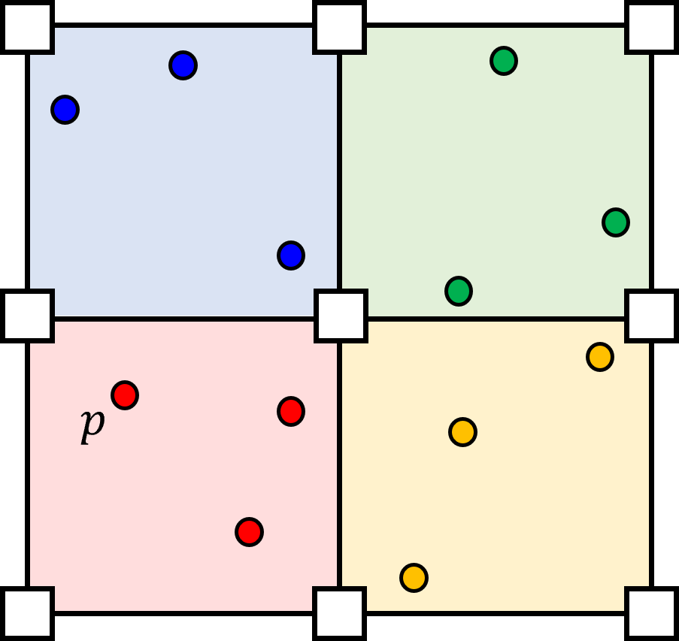
Figure 10. Every particle 𝑝 has its own independent displacement $u_{p}$, but particles within the same grid cell (denoted by color) have the same averaged pressure.

An example of the proper input is shown below in Figure 11.

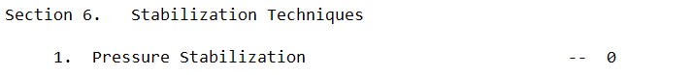
Figure 11. Example “Stabilization Techniques” input. Note: an input of “1” means pressure stabilization is used, an input of “0” means pressure stabilization is not used.

Stabilization for Linear Elastic Material
When using a linear elastic material model, the pressure stabilization technique is performed as follows.

First, the volumetric component of the strain tensor is averaged within each background grid cell. To do this, the strain tensor is first split into volumetric and deviatoric parts:
$$ε_{p}=ε_{p}^{vol}+ε_{p}^{dev}$$ | (18)
Where $ε_{p}^{vol}$ is the volumetric component and $ε_{p}^{dev}$ is the deviatoric components of the particle strain tensor, respectively, given as:
$$ε_{p}^{vol}=\frac{1}{3}tr\left(ε_{p}\right)I$$ | (19)
$$ε_{p}^{dev}=ε_{p}-ε_{p}^{vol}$$ | (20)
To perform the pressure projection, $ε_{p}^{vol}$ is then recalculated using the following background grid cell averaging scheme:
$${\overline{ε}}_{p}^{vol}=\frac{1}{3}tr\left(ε_{C}\right)I$$ | (21)
Where $tr\left(ε_{C}\right)$ represents the volume change of the background grid cell, given as:
$$tr\left(ε_{C}\right)=\frac{\sum_{p∈Ω_{C}}^{ }{m_{p}tr\left(ε_{p}\right)}}{\sum_{p∈Ω_{C}}^{ }{m_{p}}}$$ | (22)
The updated strain tensor ${\overline{ε}}_{p}$ is then recalculated as:
$${\overline{ε}}_{p}={\overline{ε}}_{p}^{vol}+ε_{p}^{dev}$$ | (23)

Stabilization for Hyperelastic Material
For the Ogden neo-Hookean material model, the volumetric component of the deformation gradient is averaged within each background grid cell. To do this, the particle deformation gradient is first split into volumetric and deviatoric parts:
$$F_{p}=F_{p}^{dev}F_{p}^{vol}$$ | (24)
Where:
$$F_{p}^{dev}=\frac{F_{p}}{{\left(J_{p}\right)}^{\frac{1}{d}}}$$ | (25)
$$F_{p}^{vol}={\left(J_{p}\right)}^{\frac{1}{d}}I$$ | (26)
Where $J_{p}=det⁡(F_{p})$ and $d$ is the spatial dimension ($d=3$ for 3D).

To perform the pressure projection $F_{p}^{vol}$ is then recalculated using a background grid cell averaged determinant:
$${\overline{F}}_{p}^{vol}={\left(J_{C}\right)}^{\frac{1}{d}}I$$ | (27)
Where $J_{C}$ is the cell averaged determinant, calculated as:
$$J_{C}^{t_{n}}=\frac{\sum_{p∈Ω_{C}}^{ }{V^{t_{n}}}}{\sum_{p∈Ω_{C}}^{ }{V^{t_{0}}}}=\frac{\sum_{p∈Ω_{C}}^{ }{V^{t_{0}}J_{p}^{t_{n}}}}{\sum_{p∈Ω_{C}}^{ }{V^{t_{0}}}}$$ | (28)
Where $J_{C}^{t_{n}}$ represents the volume change of the background grid cell from time $t_{0}$ to time $t_{n}$.

The updated deformation gradient ${\overline{F}}_{p}$ is then recalculated as:
$${\overline{F}}_{p}=F_{p}^{dev}{\overline{F}}_{p}^{vol}$$ | (29)

Remark: The code will automatically choose which stabilization technique to use, based on the material model chosen.

Fixed Boundary
The “Fixed Boundary” refers to the list of surfaces such that the displacement for each surface is to be fixed as $u\left(x\right)=0$ such that $x∈Ω_{d}$ throughout the entire simulation. An example of the proper input is shown below in Figure 12.

Figure 12. Example “Fixed Boundary” input. Note: if there are no fixed boundaries, “[~]” should be input.

The internal surface ID numbering system can be viewed in GMSH as shown in Figure 13 below.

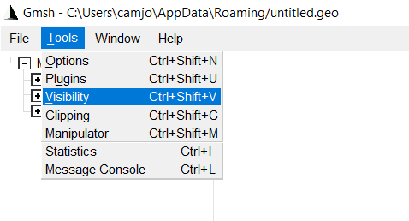
Figure 13. Screenshot within GMSH demonstrating how to view the internal surface numbering system.

Selecting “visibility” on the drop-down menu will reveal a list of geometric entities with their corresponding index, as shown below in Figure 14.

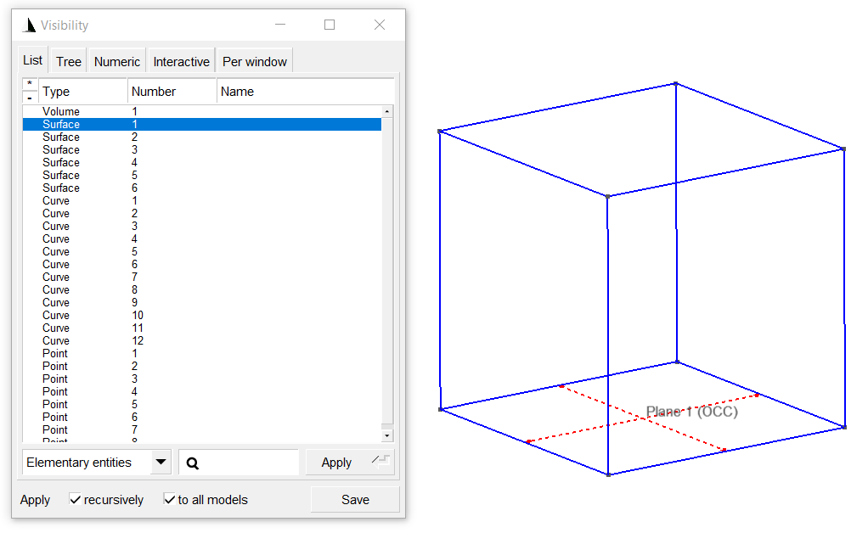
Figure 14. Screenshot within GMSH showing the internal geometric numbering system (left), and the surface geometry corresponding to the “Surface 1” label (right).

Double clicking any entity will reveal the corresponding surface geometry on the right. The indices are to be used to decide which surfaces to apply fixed boundary conditions to, when filling out the “Input File”.

Displacement Boundary
The “Displacement Boundary” refers to the list of surfaces for which the surface velocity is to be fixed as $v\left(x\right)=g$ such that $x∈Ω_{d}$. The surface ID numbers are taken from GMSH as shown in the previous section 2.8. For the “Displacement Boundary”, however, the velocity of the surface must be prescribed. An example of the proper input is shown below in Figure 15.

Figure 15. Example “Displacement Boundary” input. Note: if there is more than one “Displacement Boundary”, each “Displacement Surface Velocity” should be separated by a “;” (as shown above). Note: if there are no displacement boundaries, “[~]” should be input for both the “Displacement Boundary” and the “Displacement Surface Velocity”.

Remark: The order of the velocity inputs corresponds with the order of the surface indices given.

Example Problems
In this section, a few example problems will be introduced in order to build familiarity with the MPM3D code, and in using the three files needed to run an MPM simulation.

Drop Test Tutorial
The first example is a basic drop test, in which the setup is given in Figure 16. A constant downward body force of $g=\left[0,0,-10\right]$ is applied to a cube with sides of equal length $L=0.5$.

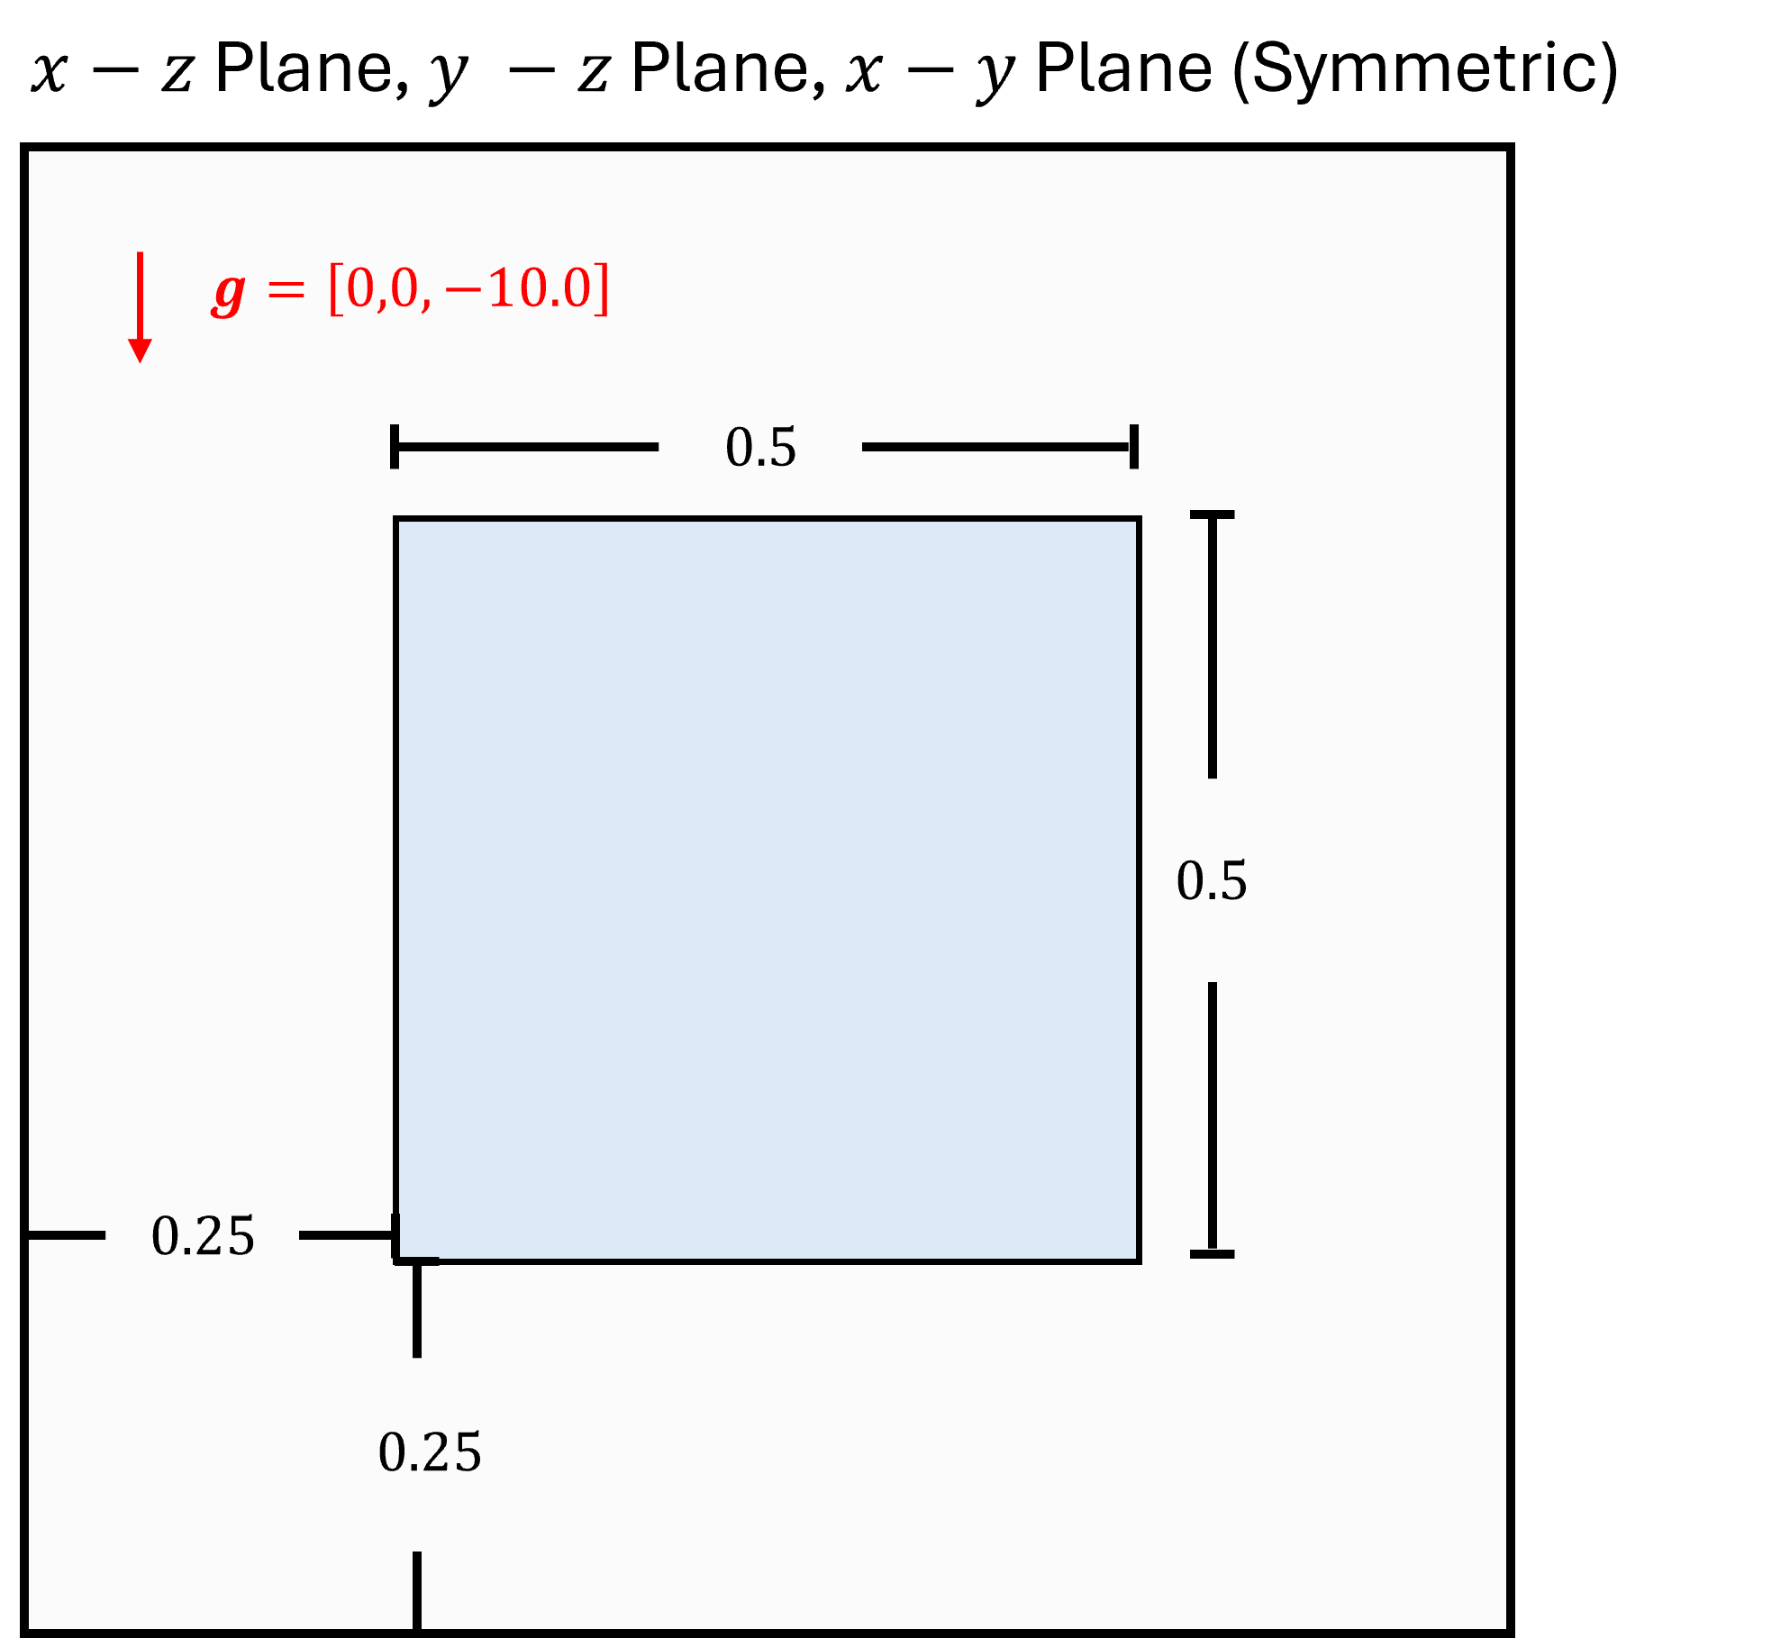
Figure 16. Problem setting for the drop test problem.

GMSH
First, the geometry and mesh must be created in GMSH. To create the cube, click the “box” option from the drop down menu on the left (Modules$→$Geometry$→$Elementary Entities$→$Add$→$Box), shown below in Figure 17.

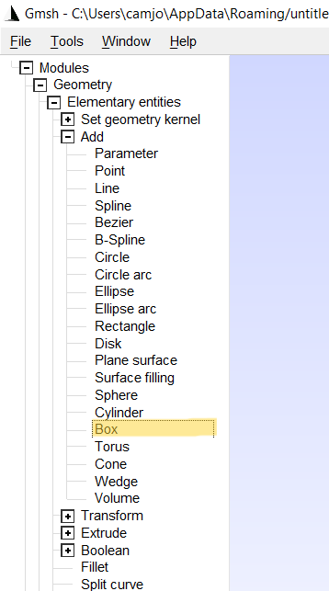
Figure 17. Screenshot within GMSH showing how to create a “box”.

Then, define the position of the base corner of the box as $\left[0.25,0.25,0.25\right]$ and the box length as $L=0.5$, shown below in Figure 18.

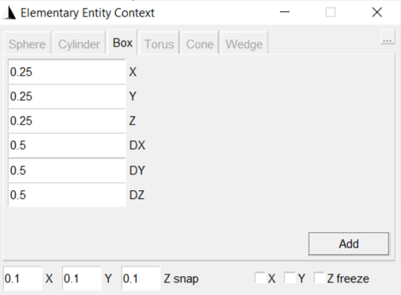
Figure 18. Screenshot within GMSH detailing the geometric dimensions of the cube.

Once the cube is created, the mesh can be defined. First, the “element size factor” has to be defined in order to set the average element length. This is done by accessing the mesh options tab (Tools$→$Options$→$Mesh$→$General). The “element size factor” should be set to 0.2, shown in Figure 19.

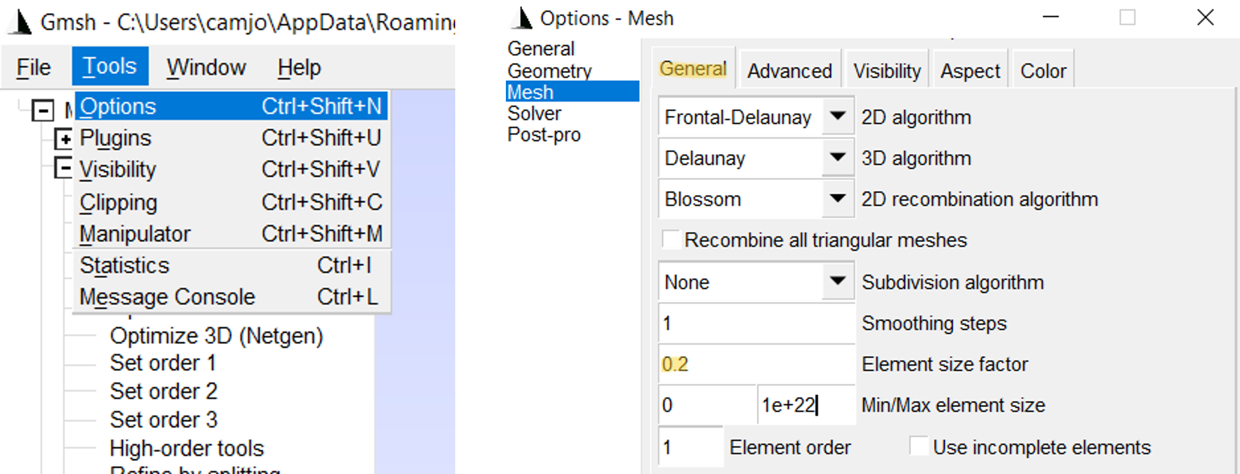
Figure 19. Screenshot within GMSH detailing where to change the “element size factor”.

Once the “element size factor” is defined, the mesh can be generated. To do so, click the “3D” option from the mesh dropdown menu (Modules$→$Mesh$→$Define$→$3D), shown in Figure 20.

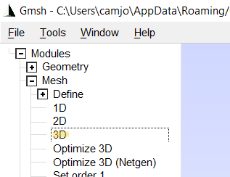
Figure 20. Screenshot within GMSH detailing how to generate the mesh.

Next, we need to export the mesh as a .msh file. To do so, click on the “Export” option from the “File” dropdown on the top left (File$→$Export). Name the file and include the $.msh$ extension (use file type “Guess from Extension”). Finally, export the mesh as “Version 4 ASCII” with both the “Save all elements” and “Save parametric coordinates” boxes checked. Refer to Figure 21 below for details.

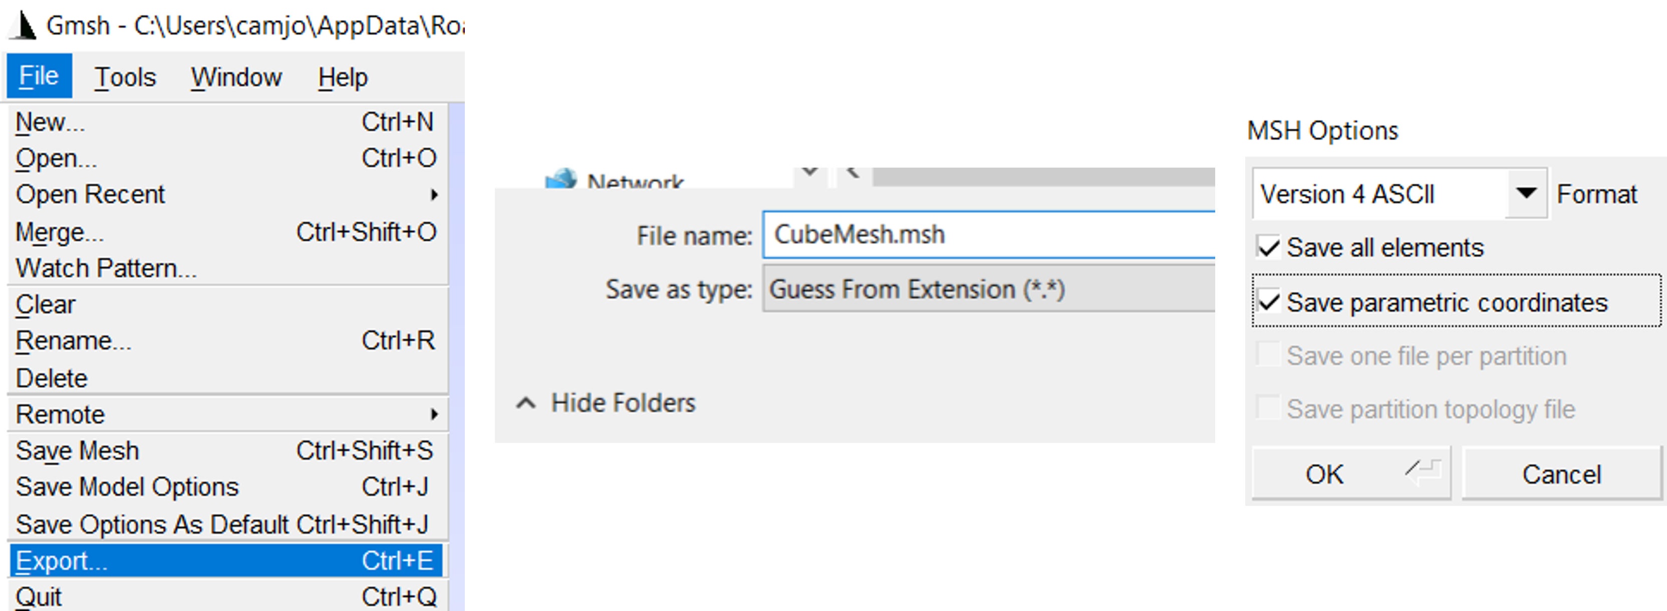
Figure 21. Screenshot within GMSH detailing how to export the mesh.

Input File
Now that the mesh is generated, we can fill out the “Input File” with the problem setting and parameter information. The “Input File” used for this simulation is shown below in Figure 22, and should be reproduced exactly for this problem.

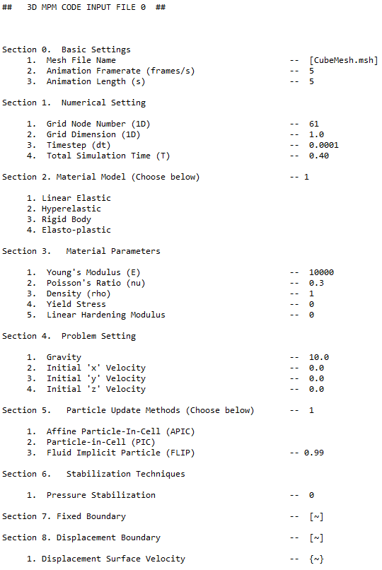
Figure 22. Input file for the “Drop Test Tutorial” problem.

Running the Simulation
Finally, we can run the simulation. The first step is to run the “Initialization File” (MAIN_Initialize.py). Running this file will generate a folder named “Initialize”. This folder contains a list of $.csv$ files denoting the geometric and index information (explained in Section 1), as well as a figure detailing the particle distribution. The contents of the “Initialize” folder are shown below in Figure 23.

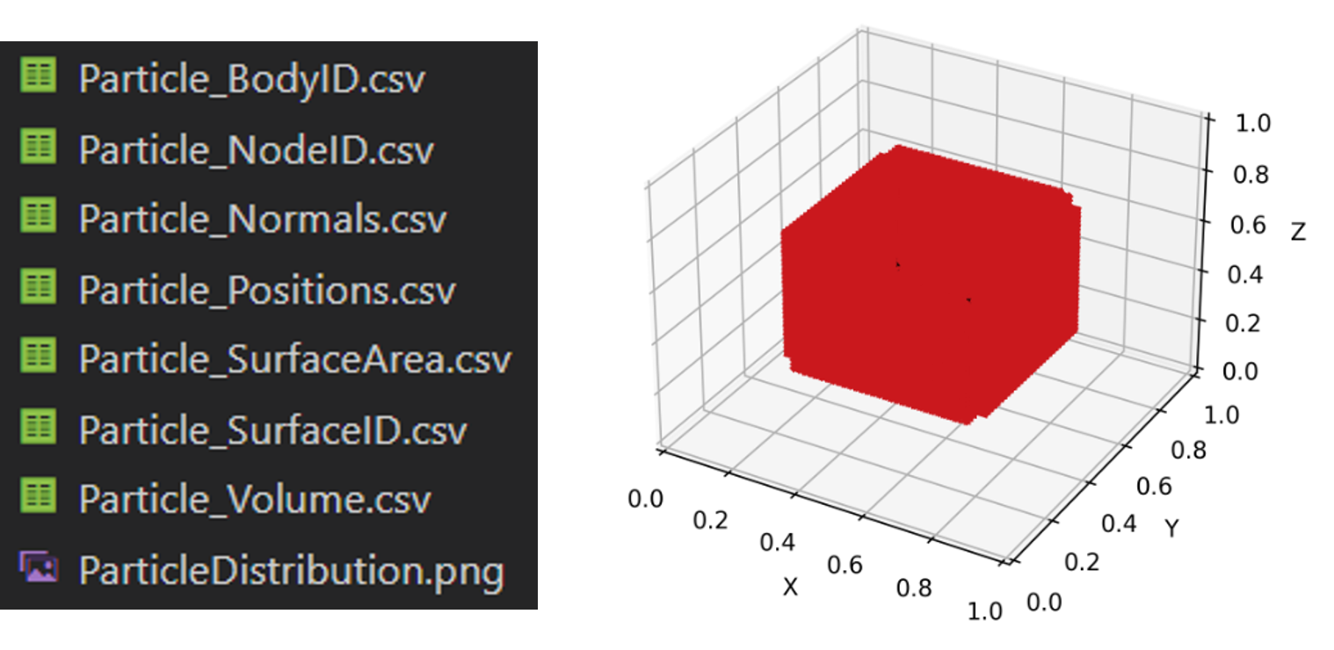
Figure 23. The $.csv$ files and the “Particle Distribution” plot generated by running the “Initialization File”. Note: The “Particle Distribution" plot visualizes both the particle locations (black) and boundary normal vectors (red). To get a clearer picture, the lengths and thicknesses of the normal vectors and particles can be adjusted near the end of the code (lines 143 - 147).

Once the “Initialization File” is run, the final step is to officially run the “Main File” (MAIN.py). After running, the code will generate a folder named “vtk” shown below in Figure 24. This folder contains the particle information for each timestep, can be visualized using ParaView. Another folder labeled “Movie” will also generate 2D screenshots of the $x-z$ plane throughout the simulation (and is a good way to monitor the simulation while it is running). Once the simulation is finished running, the next step is to visualize the data using ParaView.

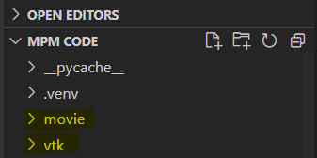
Figure 24. The “vtk” and “Movie” folders generated by the “Main File”.

Paraview
First, the $.vtk$ files must be opened from ParaView. The “Open” option is located in the top left corner of ParaView, where the “vtk” folder must be located from your computer (from wherever you downloaded / saved it to). Then, double click on the $points.vtu$ group located within the “vtk” folder to open it in ParaView (Open$→$vtk$→$points.vtu).

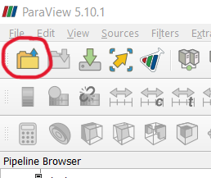

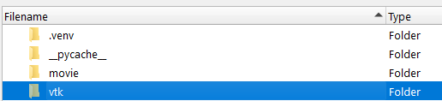

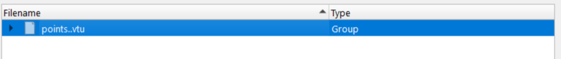
Figure 25. Top: locate the “Open” icon in the top left corner. Middle: Locate the “vtk” folder on your computer. Bottom: Double click on the $points.vtu$ group to access the data.

To visualize the data, click on the green “Apply” button on the middle-left side of ParaView. The MPM visualization will then appear on the “RenderView” on the right, shown in Figure 26.

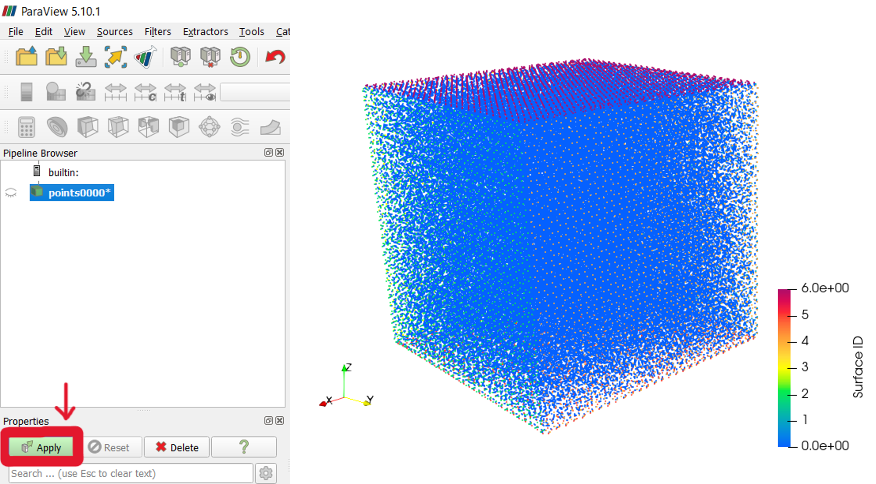
Figure 26. Left: Click the “Apply” button to visualize the MPM simulation data. Right: The MPM simulation data that appears.

The simulation is run by pressing the “Play” button on the top, shown in Figure 27.

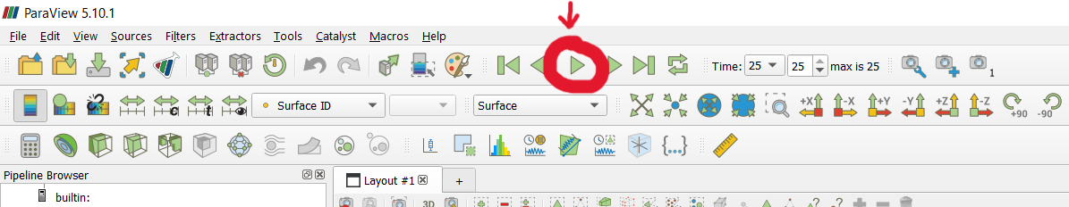
Figure 27. The “Play” button to run the simulation.

There are two options to run the simulation, the other is accessed by making sure the “Animation View” is visible under the “View” dropdown menu, shown in Figure 28.

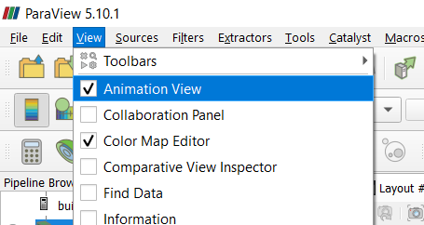
Figure 28. Make sure the “Animation View” bar is checked.

Then, the simulation can be run in “Real Time” by changing the “Mode” within the “Animation View”, shown in Figure 29. When using “Real Time”, the start frame, stop frame, and simulation duration can be easily adjusted.

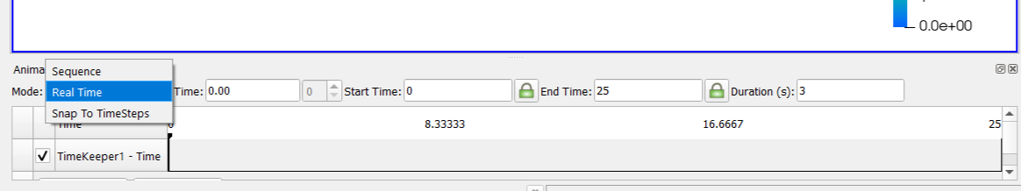
Figure 29. Switching to “Real Time” using the “Animation View”.

The animation can be saved by going to File$→$Save Animation on the top left corner of ParaView, shown in Figure 30. After choosing a name for the file (shown as $CubeAnimation.avi$), the “Save Animation Options” window will open where you can choose options including the background color, the framerate and frame window, etc., shown in Figure 31.

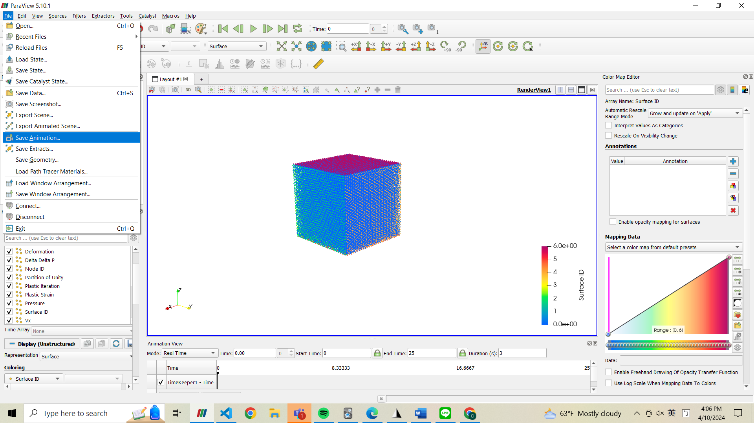

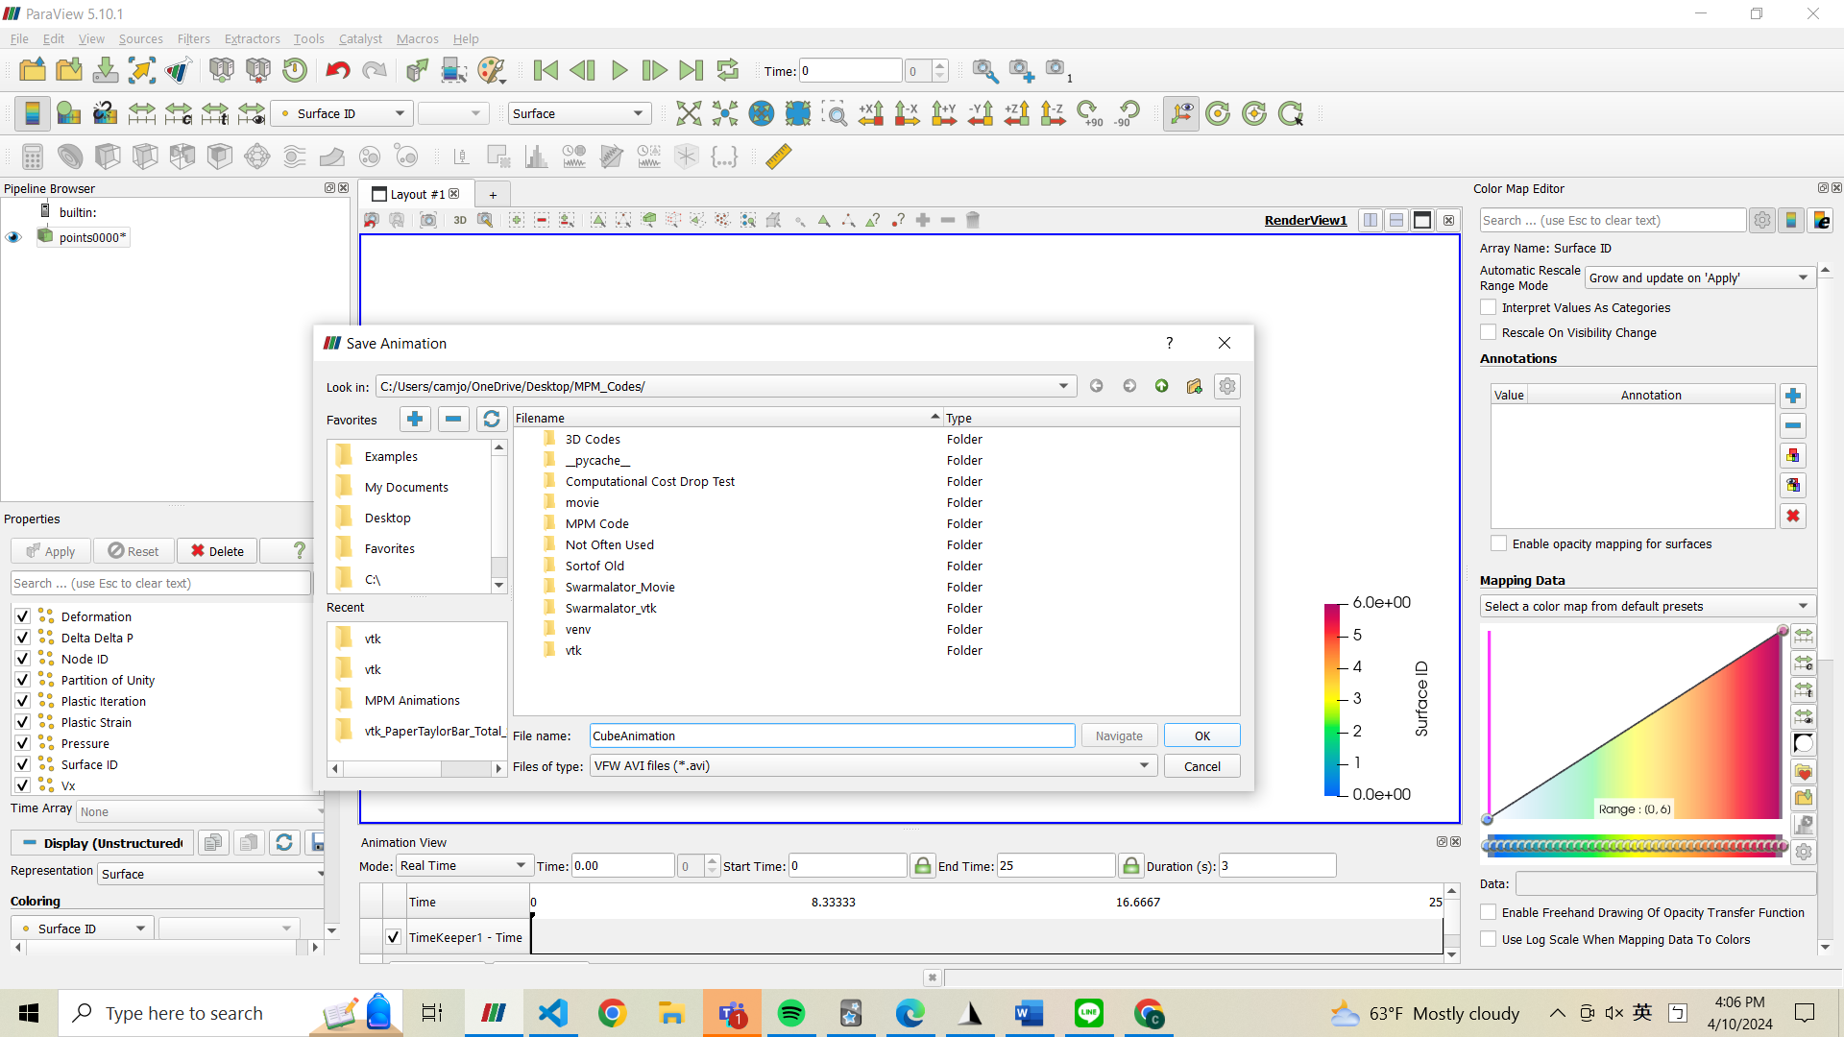
Figure 30. Saving the animation as an $.avi$ file.

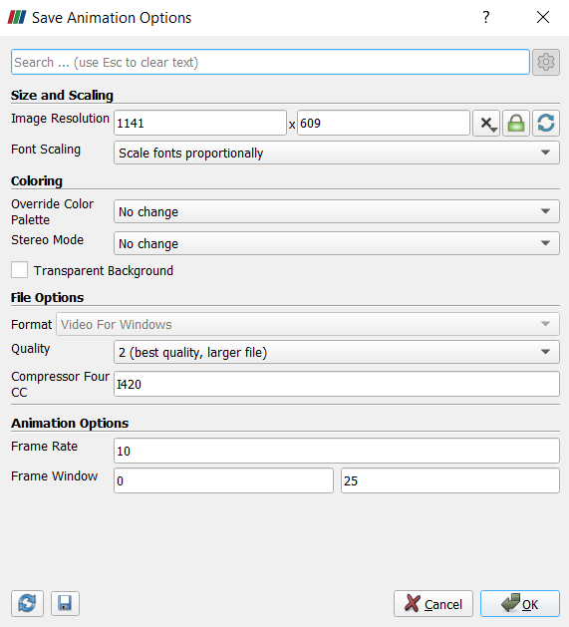
Figure 31. “Save Animation Options” to export the simulation animation.

Drop Test
As an example to practice running your own simulation, an additional drop test is introduced. In this case, the drop test involves two cubes. The problem setting is shown below in Figure 32.

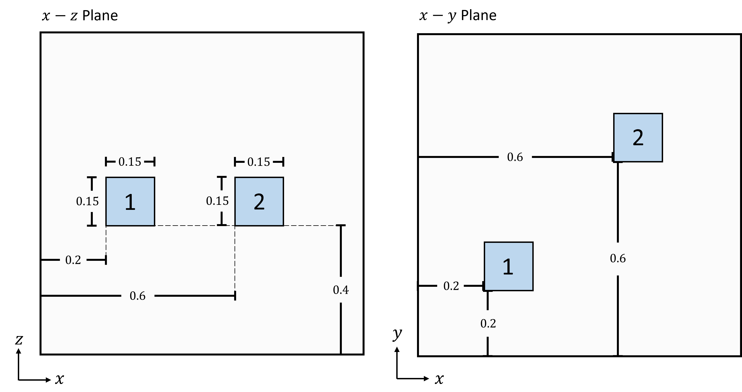
Figure 32. Problem setting for the multi-body drop test problem.
Cube #1 is hyperelastic, and cube #2 is elasto-plastic. The material properties are shown below in Table 1. A constant body force of $g=\left[0,0,-10\right]$ is applied to both bodies, which are initially at rest. The background grid is discretized into $61×61$ grid nodes, with dimension $1×1$. The timestep and total simulation time are $dt=1e-4$ and $T=0.75$. The APIC formulation is used. The “Animation Framerate” and “Animation Length” are both given as 5 (used to compare results frame-by-frame later in Section 3.2.2). Number of particles.

Table 1. Material parameters for the multi-body drop test problem.
 | Cube #1 (Hyperelastic) | Cube #2 (Elasto-plastic)
$$E$$ | $$10,000$$ | $$10,000$$
$$ν$$ | $$0.2$$ | $$0.3$$
$$ρ$$ | $$1$$ | $$1$$
$$σ_{Y}$$ | $$N/A$$ | $$8$$
$$h$$ | $$N/A$$ | $$0$$

Using Additional Input Files
This problem involves multiple bodies, which requires the use of multiple “Input Files”. The code uses a general rule of one “Input File” per body.

The first “Input File” (Input_0.txt) defines the overall problem setting for all bodies, as well as a fixed set of parameters for the first body. Any “Input File” used in addition to the first one must be named using an increasing index (Input_1.txt, Input_2.txt, Input_3.txt, etc.), and defines the same fixed set of parameters for any additional body. Any additional “Input File” used will only include sections 2 – 4 (“Material Model”, “Material Parameters”, and “Problem Setting”), which are the only sections that can be defined separately for each body (using the current state of the code).

In addition, it is also required that each body uses its own $.msh$ file. Therefore, the geometry for each body must be created separately in GMSH. For this drop test example, the two cubes are generated separately in GMSH, and each uses its own $.msh$ file.

Remark: Although each body uses its own $.msh$ file, the files are all input into the first “Input File” (Input_0.txt). You can reference the example in Figure 1.

Results
After running the simulation and opening the $.vtk$ files into ParaView, we want to be able to meaningfully compare the material behavior for each of the two cubes. To do this, for this example we want to display each cube’s pressure field throughout the simulation.

In order to show the pressure field, you can select the “Pressure” option from the dropdown menu on the top left corner of ParaView, as shown in Figure 33.
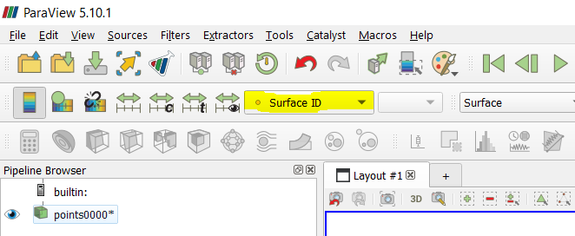
Figure 33. Accessing the various field options from the dropdown menu using ParaView.

The pressure bar scale can also be adjusted by selecting the “Rescale to Custom Data Range” icon shown in Figure 34 below.

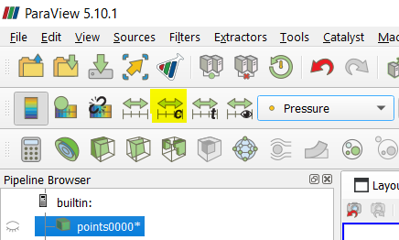
Figure 34. The “Rescale to custom data range” icon is used to adjust the scale of the current visualization parameter.

You can also experiment with visualizing the other various fields available, other than the pressure field.

Initially, the pressure field is difficult to visualize due to the small size of each particle. In order to adjust the particle size within ParaView, you can also select the “Point Gaussian” option from the “Representation” drop down menu on the left. You can choose the “Shader Preset” to be “Plain Circle”, and adjust the “Gaussian Radius” to choose an appropriate particle size.

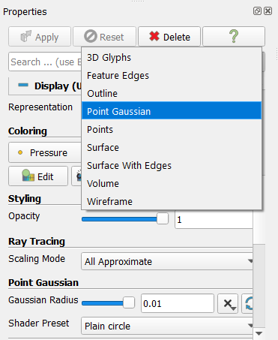
Figure 35. Using “Point Gaussian” as the particle visualization option to easily adjust particle size.

The pressure field results at frame 11 / 25 of the simulation are shown below in Figure 36. Here, we can see severe pressure instability present in both cubes, for reasons mentioned in Section 2.7. This is especially true for the elasto-plastic cube.

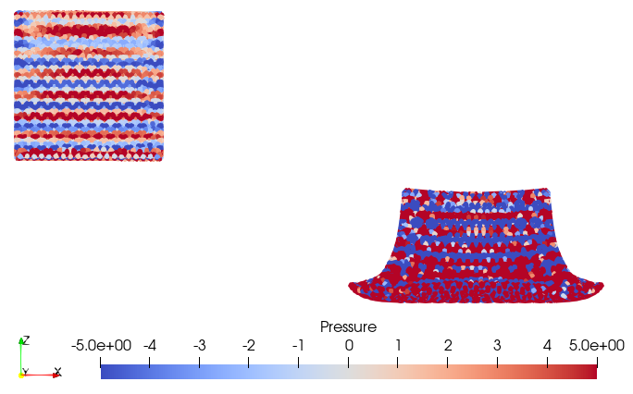
Figure 36. The pressure field at framerate 11 / 25 for the multi-body drop test problem. Shown using the “2D” function in ParaView”.

The problem was then re-run after turning on the “Pressure Stabilization” switch, to implement the F-Bar projection technique and help alleviate the severe pressure oscillation. The results for frame 11 / 25 of the resulting simulation are shown below in Figure 37.

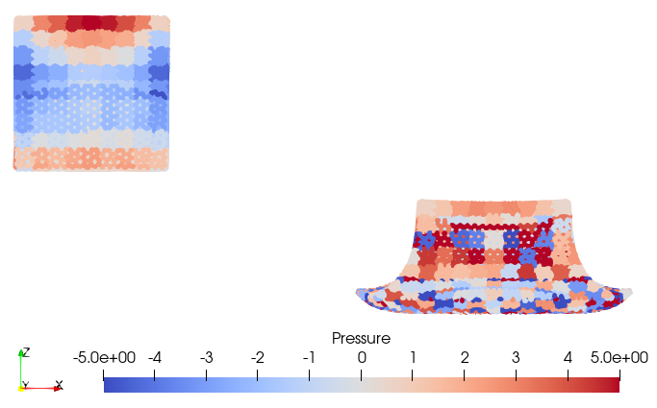
Figure 37. The pressure field at framerate 11 / 25 for the multi-body drop test problem, with the additional F-Bar projection technique. Shown using the “2D” function in ParaView”.

Here, the pressure field for both the hyperelastic and elasto-plastic cubes is significantly improved.

As an additional example, the same drop test simulation can be run with other “Particle Update Methods” other than the APIC formulation used in the results above. The results for the same simulation when using PIC, APIC, and FLIP99 are shown below in Figure 38.

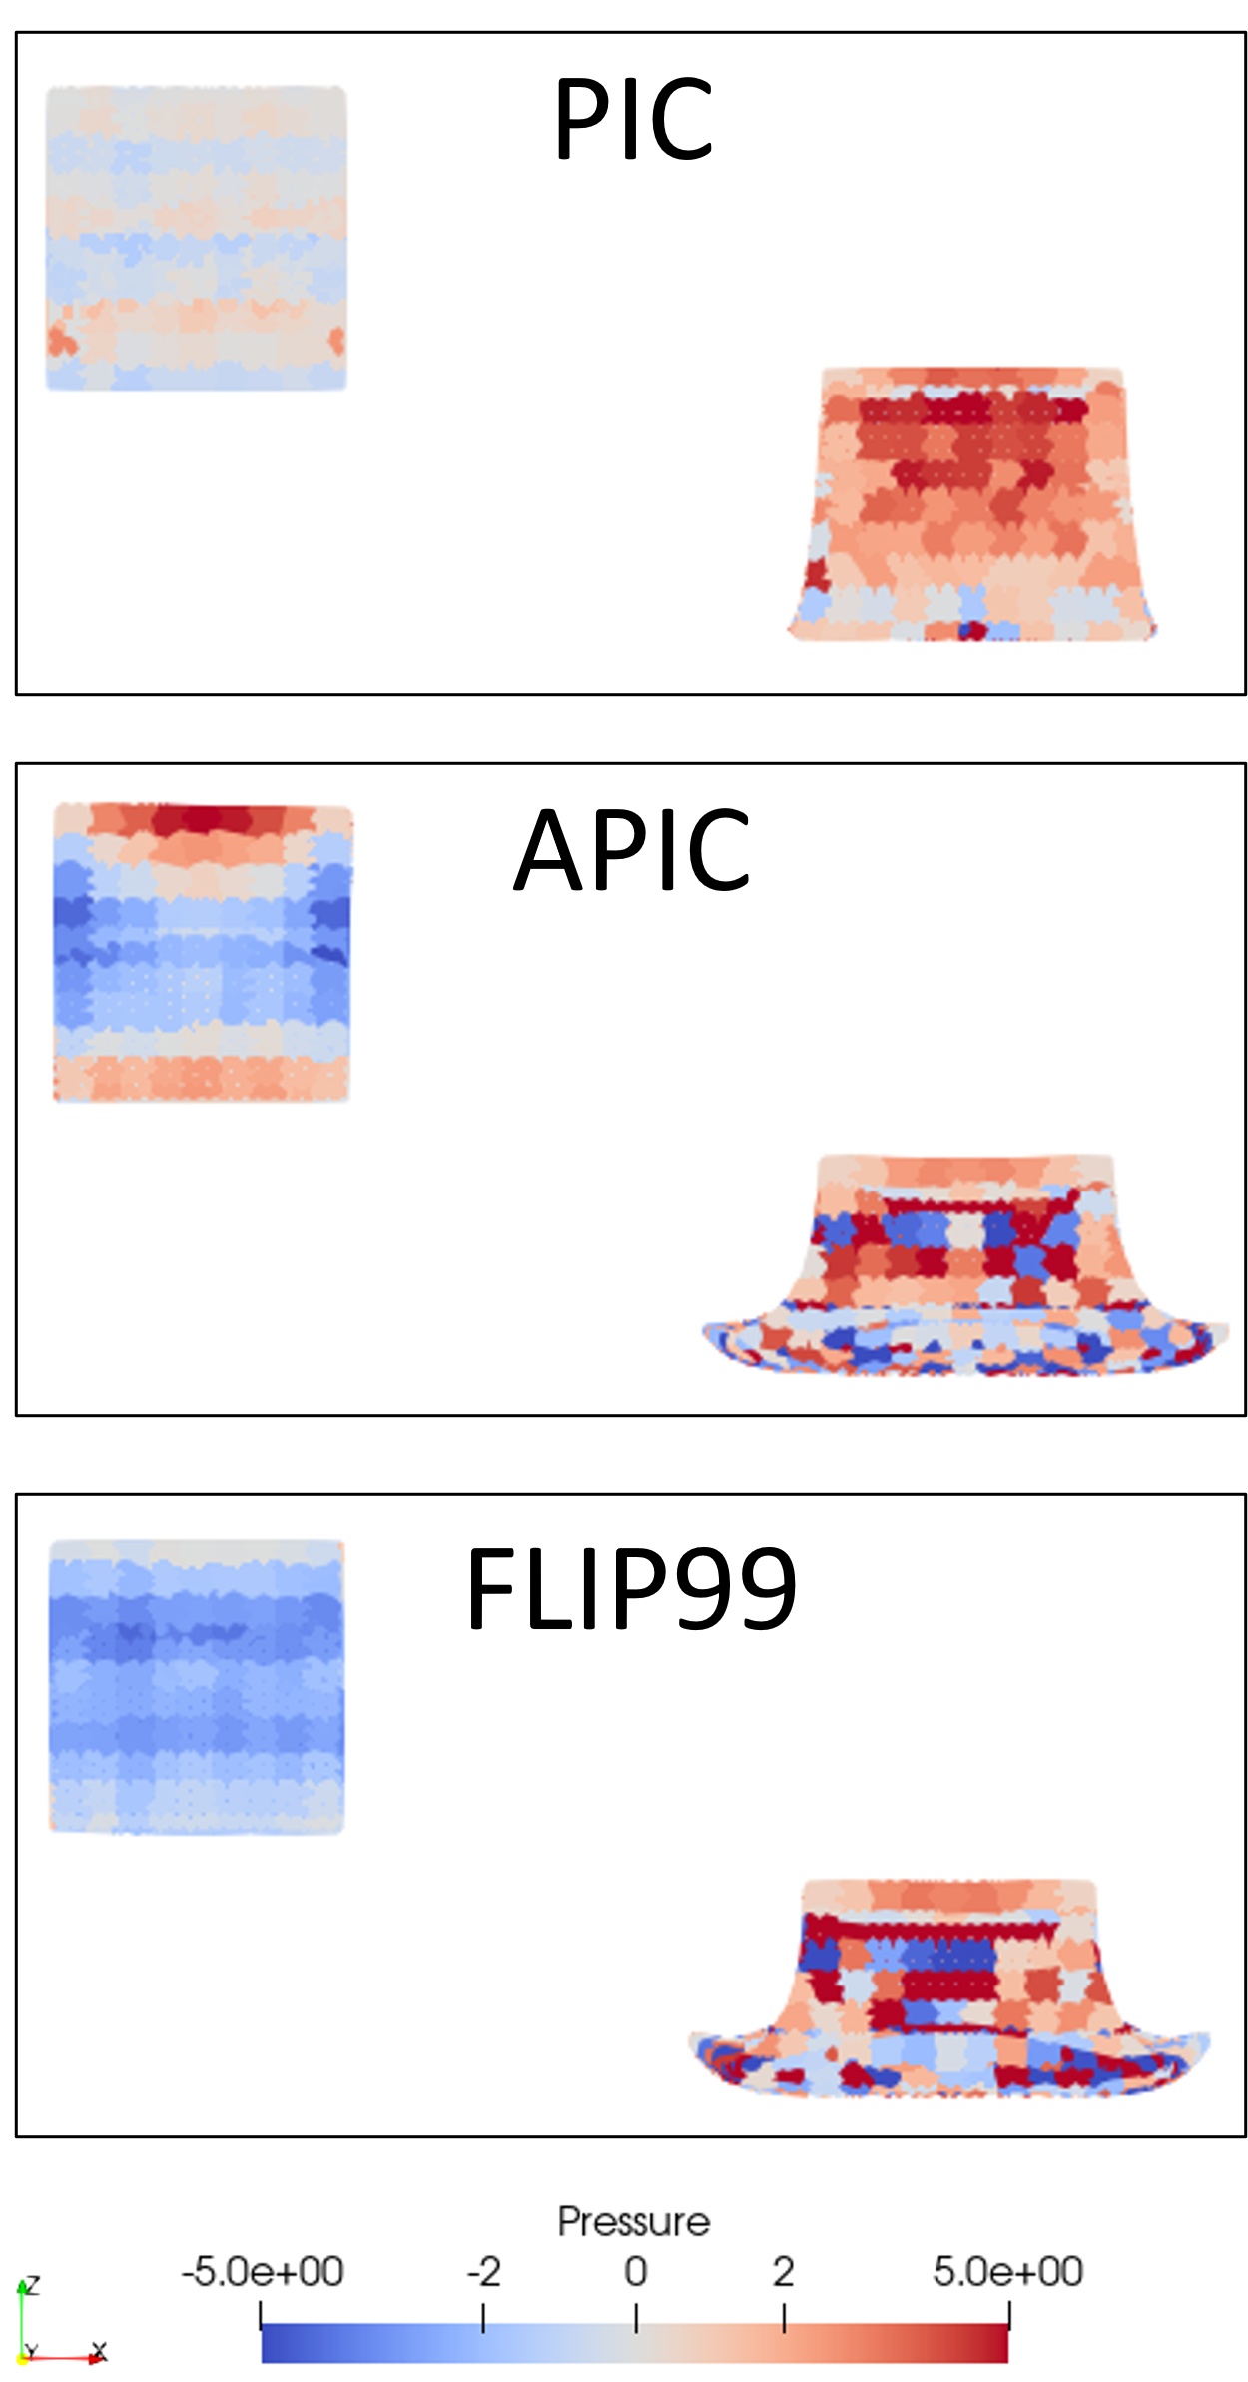
Figure 38. The pressure field at framerate 11 / 25 for the multi-body drop test problem, using PIC, APIC, and FLIP99. Each simulation uses the additional F-Bar projection technique. Shown using the “2D” function in ParaView”. Note: FLIP99 refers to the blending of FLIP and APIC, where $α=0.99$ (see Section 2.6.3).

Punch Test
A punch test example is given, in order to practice a multi-body problem that includes the implementation of boundary conditions. The problem setting is shown below in Figure 39.

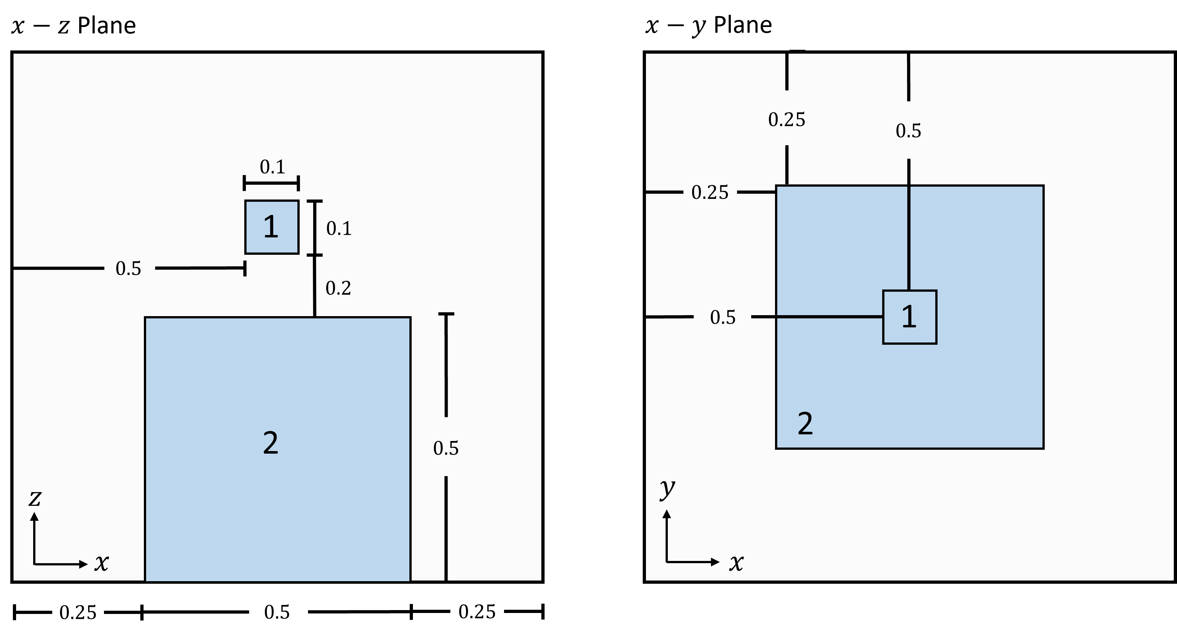
Figure 39. Problem setting for the multi-body punch test problem.

Cube #1 is hyperelastic, and cube #2 is a rigid body. The material properties are shown below in Table 2. Cube #2 is given an initial downward velocity of $v=[0,0,-0.3]$, whereas Cube #1 is initially at rest. Cube #1 is fixed ($u=0$) on all boundary surfaces except for the top surface. The background grid is discretized into $25×25$ grid nodes, with dimension $1×1$. The timestep and total simulation time are $dt=1e-4$ and $T=1.0$. The APIC formulation is used. The “Animation Framerate” and “Animation Length” are both given as 5. The number of particles for the bottom cube and top cube are 10,400 and 1,191, respectively.

Table 2. Material parameters for the multi-body punch test problem.
 | Cube #1 (Hyperelastic) | Cube #2 (Rigid Body)
$$E$$ | $$2,000$$ | $$N/A$$
$$ν$$ | $$0.49$$ | $$N/A$$
$$ρ$$ | $$1$$ | $$N/A$$
$$σ_{Y}$$ | $$N/A$$ | $$N/A$$
$$h$$ | $$N/A$$ | $$N/A$$

Surface Index Definition When Using Multiple Bodies
When modeling problems with multiple bodies, the surface boundary indexing system used to define the “Fixed Boundary” and “Displacement Boundary” gets slightly complicated. Because each mesh is generated independently in GMSH, the indexing system is local to each body. However, we want an indexing system that is global, as in a system that includes all bodies. Therefore, when setting the “Fixed Boundary” and “Displacement Boundary”, the index system given by GMSH (shown in Figure 14) cannot be used.

The MPM 3D code will deal with the indexing on its own. However, in order to know which surfaces correspond to which indices, the simulation result must be run in ParaView first. In ParaView, the “Surface ID” can be displayed, as shown in Figure 40.

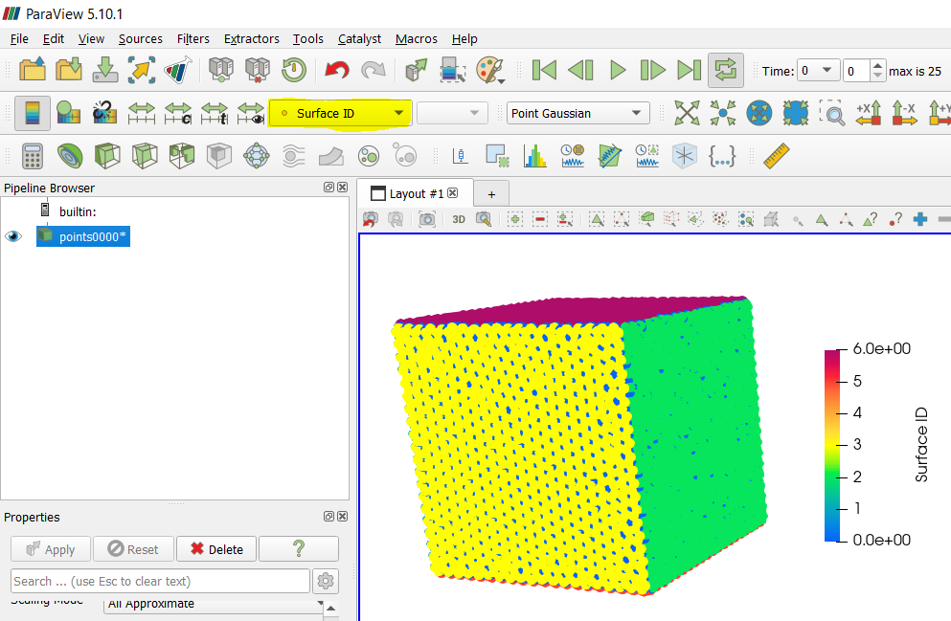
Figure 40. Displaying the “Surface ID” in ParaView to visualize the surface indices.

Remark: To view the “Surface ID” within ParaView, it is not necessary to run the entire simulation. Only one timestep is necessary. Therefore, you can run the first timestep of the simulation without any boundary conditions applied, in order to first determine the proper surface indices to apply boundary conditions. Then, you can input the correct boundary conditions and run the full simulation.

Results
For this example, the best way to display the pressure field of each body is by using a cross-section view. To do this in ParaView, we can use the “Clip” tool shown below in Figure 41.

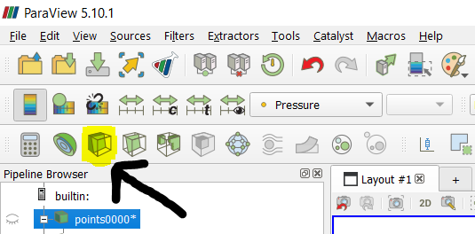
Figure 41. ParaView’s “Clip” tool.

Next, select the “Box” option from the “Clip Type” dropdown menu as shown in Figure 42. Define the geometry of the “Box” (“Position”, “Rotation”, and “Length”) as given, then click “Apply”.

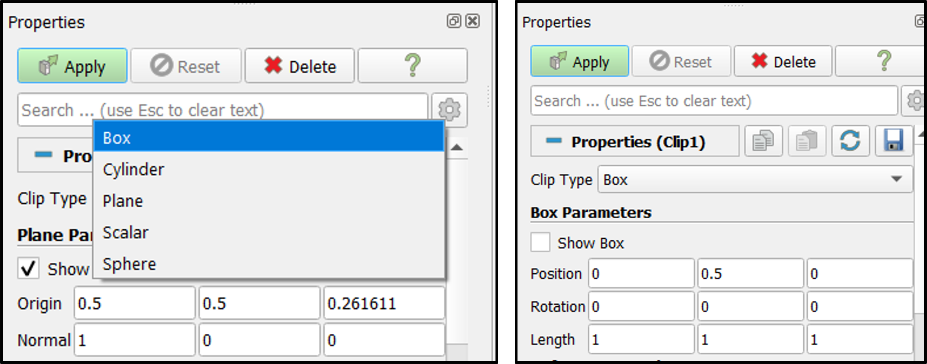
Figure 42. Left: select the “Box” option from the “Clip Type” dropdown menu. Right: Define the geometry of the “Box” as shown.

Finally, the pressure field for the punch test problem for frame 25 / 25 is given below in Figure 43. Here, the results with and without the F-Bar pressure projection technique are shown together.

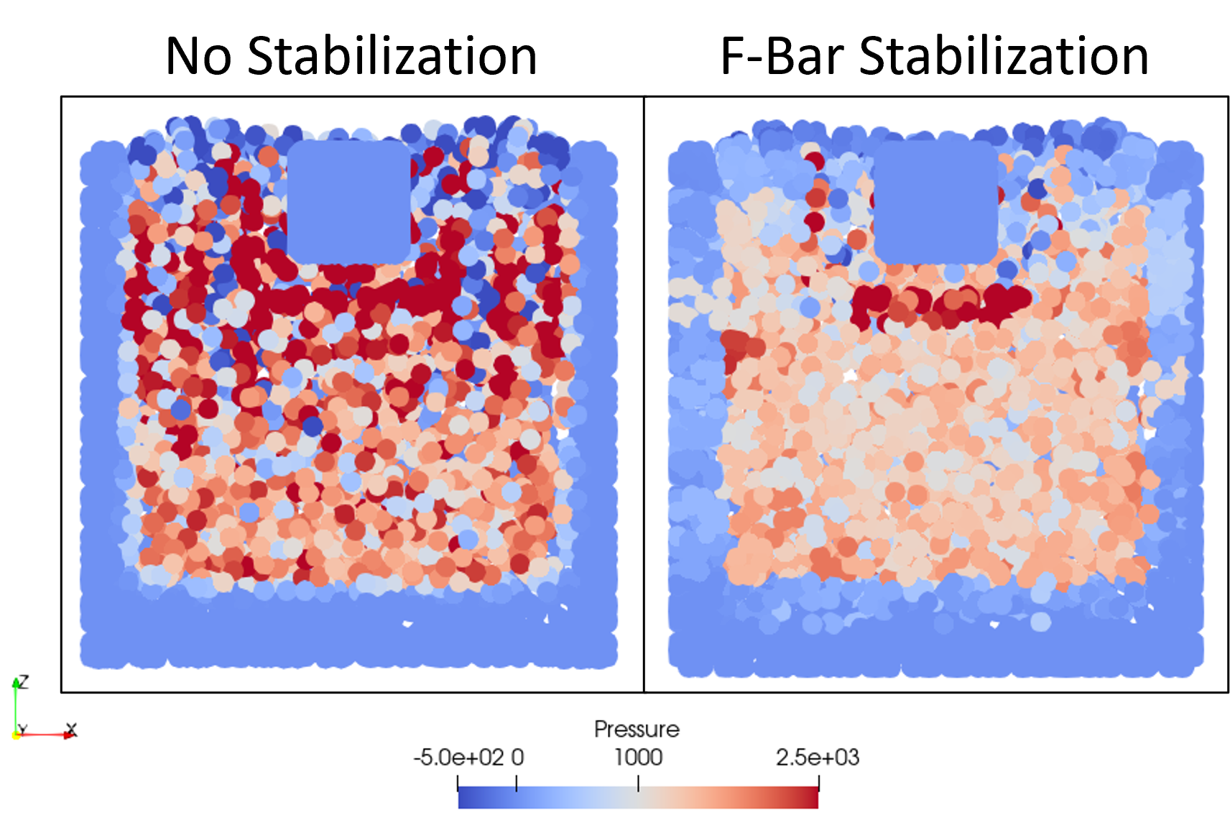
Figure 43. The pressure field at framerate 25 / 25 for the multi-body punch test problem for both with and without the additional F-Bar projection technique. Shown using the “2D” function in ParaView”.

Other Notes
- The current stage of this code only works for Taichi version 1.2.0!
  - Taichi version 1.2.0 can only run on Python version 3.10 and before

- Make sure you have all libraries installed
  - gmsh
  - numpy
  - matplotlib
  - pyevtk
  - taichi (version 1.2.0)

